THE ARK OF REDEMPTION  REQUEST FOR VOLUNTEER APPLICANT INFORMATION AND RELEASE FORM  Email: redemptioncatrescue@yahoo.com  Phone: 614-356-5555 | 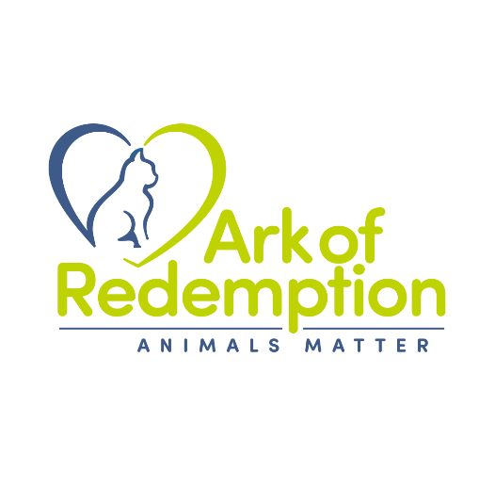

The Ark of Redemption was created for the purpose of rescuing unwanted and abused companion animals. All of our pets are placed in foster homes until they are adopted by an approved home. The Ark of Redemption is staffed solely by volunteers who love and want to help homeless animals. We always need volunteers and thank you for your interest in joining this organization.
Name
Address

Home phone #
Employer name and Work phone #
Email address:
Do you currently own any pets? If so, please list them all below:

Why do you want to volunteer with The Ark of Redemption?

Please list 3 personal or professional references.
1. Name:
Address:

Phone Number:
Relationship:
Length of time known:

2. Name:
Address:

Phone Number:
Relationship:
Length of time known:

3. Name:
Address:

Phone Number:
Relationship:
Length of time known:

What hobbies do you have? How do you like to spend your free time?

What days and times are you available to volunteer?

RELEASE
1. I agree to release, discharge, indemnify and hold The Ark of Redemption harmless for any and all damage to my personal property while performing as a VOLUNTEER in a VOLUNTEER CAPACITY any and all duties for The Ark of Redemption.
2. I recognize that in handling animals for The Ark of Redemption in a VOLUNTEER CAPACITY there exists a risk of injury or sickness, including personal injury or harm. On behalf of myself, my heirs, personal representatives and executors, I hereby release, discharge, indemnify, and hold harmless The Ark of Redemption and its agents from any and all claims, causes of actions or demands, of any nature or cause connected with my Volunteer Agreement. This might include connection with my VOLUNTEER services based on damages that may be incurred or sustained by me in any way. Such damages or injuries might include, but are not limited to animal bites, accidents, injuries, and personal property damage.

3. I understand that public relations are an important part of volunteering with The Ark of Redemption. I agree, therefore, on behalf of myself, my heirs, personal representatives, and executors to allow The Ark of Redemption to use any photograph or video recording taken of me for use in public relations efforts. Any photographic or video images that I produce, in a VOLUNTARY CAPACITY, will become the sole property of The Ark of Redemption Rescue Ohio and as such, it may use them in any ways it sees fit. The Ark of Redemption will use reasonable efforts to notify me but such notification is not a condition of use hereunder.
4. I will conduct myself in an appropriate manner in public when acting as a representative of The Ark of Redemption.
5. I am over the age of 18 at the time of signing this agreement.

I ACKNOWLEDGE THAT I HAVE READ AND UNDERSTAND THE TERMS AND CONDITIONS OF THE FOREGOING VOLUNTEER AGREEMENT AND RELEASE AND THAT I WILL COMPLY WITH THE SAME. ALL OF THE INFORMATION PROVIDED IS TRUE AND CORRECT TO THE BEST OF MY KNOWLEDGE.

Signature | Date

